**National University of Computer & Emerging Sciences, Karachi Computer Science Department**

**Summer 2023, Lab Manual – 05**

|  |  |
| --- | --- |
| **Course Code: AI-2002** | **Course: Artificial Intelligence Lab** |
| **Instructor(s):** | **Sania Urooj** |

**Lab Tasks**

**Task#1:**

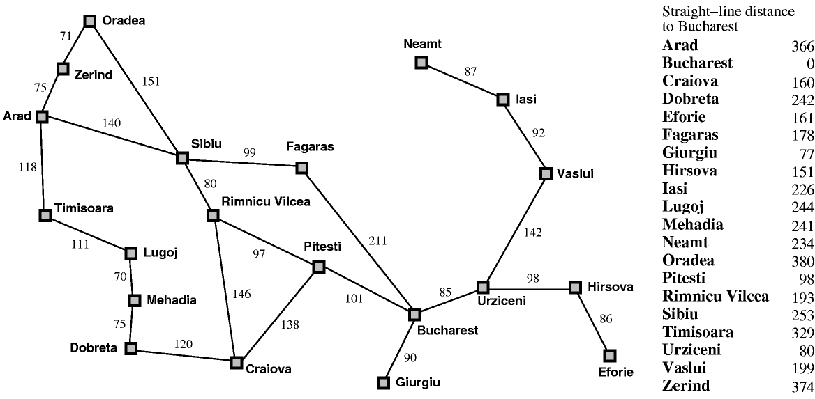In figure, the straight-line distance shows the heuristic values. Using greedy best search and A* algorithm, find the route if the goal **Bucharest**, the source is **Arad**.